DUMMY DOCUMENT
LAB MIDTERM CONDUCTED ON 05/03/2026
Ass. No: 4 Title: Secure Hash Algorithm 512 (SHA 512)
Exp. No: 5
Date: 25-02-2026
Aim:
To find the padding bits and total number of blocks required to process the original message using SHA 512 in Python

Concept:
- SHA-512 processes messages in 1024-bit blocks.

- Before hashing, the original message must be padded so its length becomes a multiple of 1024 bits.
- Padding ensures the final message length ≡ 896 (mod 1024) before adding length field.
- Padding process includes:
Append 1 bit to the message.
Append k zero bits.
Append 128-bit representation of original message length.
- Total padded message length becomes a multiple of 1024 bits.
- Number of blocks required:
$$\text{Number of Blocks}=\frac{\text{Total Padded Length}}{1024}$$
- Padding bits calculation:
$$k=(896-(L+1) mod 1024)$$
Where:
L = original message length in bits
1 = single appended ‘1’ bit
128 = bits used to store message length

Algorithm:
- Start the program.
- Input the original message length in bits.
- Store the message length in a variable L.
- Append 1 bit to the original message.
- Calculate the number of padding zero bits using the formula:
k = (896 - (L + 1) % 1024) % 1024
- Calculate the total padded message length using:
total_length = L + 1 + k + 128
- Calculate the total number of 1024-bit blocks required using:
blocks = total_length // 1024
- Display the following:
  - Original message length
  - Padding bits added
  - Total padded message length
  - Total number of blocks required
- Stop the program.

Program:
def sha512_padding(l):
o = 1
k = (896 - (l + o) % 1024) % 1024
t = l + o + k + 128
b = t // 1024

print("\nResults:")
print("Original Message Length (bits):", l)
print("Padding Bits Added (excluding 1-bit and length field):", k)
print("Total Padded Message Length (bits):", t)
print("Total Number of 1024-bit Blocks Required:", b)

print("SHA-512 Padding and Block Calculator")
print("-------------------------------------")

l = int(input("Enter the original message length in bits: "))
sha512_padding(l)

Output:
Example 1: Get the original message (700) in bits and display the padding bits and display the total number of blocks required to process it
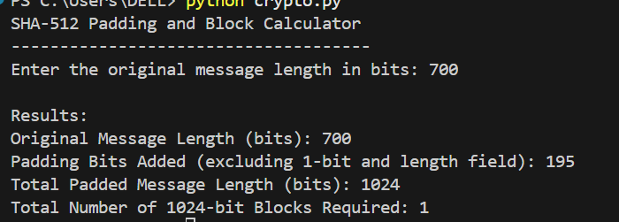
Example 2: Get another original message (your own input but it should be greater than 5000) in bits and display the padding bits and display the total number of blocks required to process it
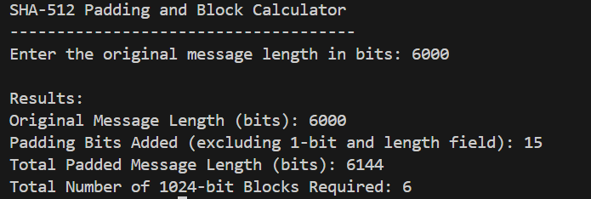

Ass. No: 4 Title: Digital Signature Standard (DSS)
Exp. No: 6
Aim:
To create the signature in the sender side and verify the signature in the receiver side using DSS in Python

Concept:
- Digital Signature Standard (DSS) is used to ensure authentication and integrity of a message.
- It uses two keys:
Private key (kept secret by sender)
Public key (shared with receiver)
- Signature is created using:
Prime numbers p and q
Private key
Random integer k
Hash value of message (h)
- At sender side:
Compute public key
Compute signature values r and s (represented here as a and b)
- At receiver side:
Compute verification parameters
Validate signature using mathematical formula
- If calculated value matches r, signature is valid.
- DSS ensures:
Authentication (sender identity)
Integrity (message not altered)
Non-repudiation (sender cannot deny sending)

Algorithm:

Sender Side
- Start the program.
- Input prime numbers p and q.
- Input original message.
- Input private key x.
- Input random integer k.
- Input hash value h of the message.
- Compute public key:
y = (g^x) mod p
- Compute:
r = (g^k mod p) mod q
- Compute:
s = (k⁻¹ (h + x*r)) mod q
- Display r, public key y, and signature values (a = r, b = s).

Receiver Side
- Compute:
w = s⁻¹ mod q
- Compute:
u1 = (h * w) mod q
- Compute:
u2 = (r * w) mod q
- Compute:
z = ((g^u1 * y^u2) mod p) mod q
- If z == r:
Signature is valid
Else:
Signature is invalid
- Stop the program.

Program:
def inv(a, m):
return pow(a, -1, m)

print("Digital Signature Standard (DSS)")
print("----------------------------------")

# User Inputs (same variables as question)
p = int(input("Enter prime number p: "))
q = int(input("Enter prime number q: "))
w = int(input("Enter message hash w: "))
h = int(input("Enter value h: "))
x = int(input("Enter private key x: "))
k = int(input("Enter random integer k: "))

# Step 1: Compute r
r = pow(h, (p - 1) // q, p)

# Step 2: Compute y
y = pow(r, x, p)

print("\n----- Sender Side -----")
print("r =", r)
print("Public Key (p, q, r, y) =", (p, q, r, y))

# Step 3: Compute signature (a, b)
a = pow(r, k, p) % q
k_inv = inv(k, q)
b = (k_inv * (w + x * a)) % q

print("a =", a)
print("b =", b)

# ----- Receiver Side -----
z = inv(b, q)
u1 = (w * z) % q
u2 = (a * z) % q
v = (pow(r, u1, p) * pow(y, u2, p)) % p % q

print("\n----- Receiver Side -----")
print("z =", z)
print("u1 =", u1)
print("u2 =", u2)
print("Verification: v == a")

if v == a:
print("Signature is VERIFIED")
else:
print("Signature is INVALID")

Output:
Example 1 (Consider our class example inputs): Get two prime numbers, original message, private key, random integer and h, display the output of r, public key, a & b in the sender side and display the output of z, u1, u2 & verification formulae in the receiver side. Get the inputs only from the user and should not declare in the program.
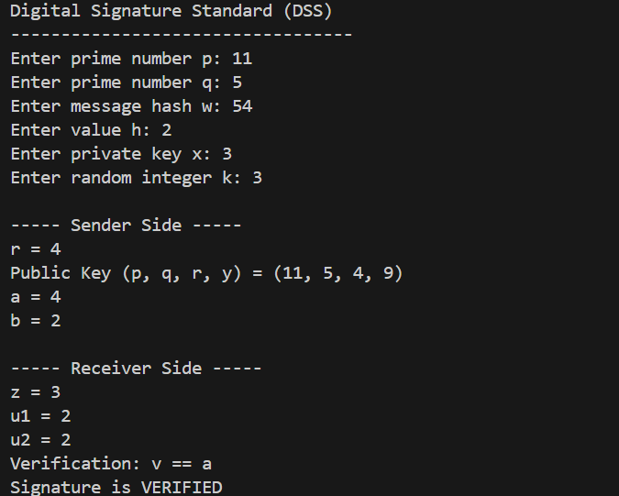

Example 2 (Consider our class exercise inputs): Get two prime numbers, original message, private key, random integer and h, display the output of r, public key, a & b in the sender side and display the output of z, u1, u2 & verification formulae in the receiver side. Get the inputs only from the user and should not declare in the program.
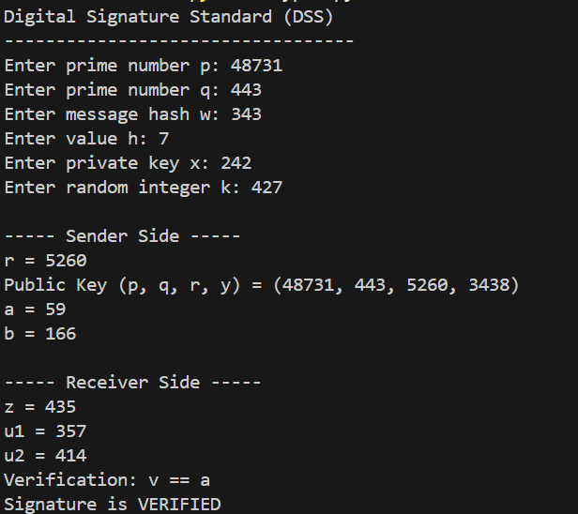

Ass. No: 4 Title: Message Digest 5 (MD5)
Exp. No: 7
Aim:
- To find the 1. Original message in binary bits, 2. Padding binary bits & 3. Length of the message in binary bits using MD 5 Python
- Find the output of MD buffers A, B, C & D of steps 1 & 2 of Round 1 MD5.

Concept:
i) Concept of Original Bits, Padding Bits and Length in MD5
- MD5 processes messages in 512-bit blocks.
- The original message is first converted into binary.
- Each character is represented using 8-bit ASCII.
- Padding is added to make the message length ≡ 448 mod 512.
- Padding process:
  - Append one ‘1’ bit.
  - Append required number of ‘0’ bits.
- Finally, append 64-bit representation of original message length.
- The total message becomes a multiple of 512 bits.
- Length is stored in little-endian format in real MD5.

ii) Concept of MD Buffers A, B, C & D (Round 1)
- MD5 uses four 32-bit buffers:
  - A
  - B
  - C
  - D
- Initial values are predefined (in real MD5).
- Round 1 uses nonlinear function:
$$F(B,C,D)=(B∧C)∨(¬B∧D)$$
- Each step updates buffers using:
  - Previous A, B, C, D
  - Message word M[i]
  - Constant K[i]
  - Left circular shift
- Step formula:
$$A=B+((A+F+M[i]+K[i])<<<s)$$
- Buffers rotate after each step.

Algorithm:

i) Algorithm for Aim (i)
- Start the program.
- Input original message in text.
- Convert each character into 8-bit binary.
- Concatenate to get full binary message.
- Compute original length in bits.
- Append one ‘1’ bit.
- Add zero bits until length ≡ 448 mod 512.
- Count total padding bits added.
- Convert original length into 64-bit binary.
- Display:
  - Original message in binary
  - Total padding bits
  - Padding bits in binary
  - Original length
  - Length in binary
- Stop.

ii) Algorithm for Aim (ii)
- Start program.
- Input MD buffers A, B, C, D.
- Input M0 and K1.
- Compute:
F = (B & C) | (~B & D)
- Compute Step 1:
A = B + left_rotate((A + F + M0 + K1), s)
- Rotate buffers (A,B,C,D).
- Display updated A, B, C, D (Step 1).
- Use Step 1 output as input.
- Input M1 and K2.
- Repeat same process for Step 2.
- Display updated buffers (Step 2).
- Stop.

Program:
# -------------------- AIM (i) --------------------

print("AIM (i) - MD5 Padding Process")
print("--------------------------------")

message = input("Enter the original message: ")

binary_message = ''.join(format(ord(ch), '08b') for ch in message)

print("\n1. Original message in binary bits:")
print(binary_message)

original_length = len(binary_message)
print("\n4. Length of original message (in bits):", original_length)

padding_length = (448 - (original_length + 1)) % 512
padding_bits = '1' + '0' * padding_length

print("\n2. Total number of padding bits:", len(padding_bits))
print("\n3. Padding bits in binary:")
print(padding_bits)

length_64bit = format(original_length, '064b')

print("\n5. Length of original message in binary (64-bit):")
print(length_64bit)

# -------------------- AIM (ii) --------------------

print("\n\nAIM (ii) - Round 1 (Step 1 & Step 2)")
print("--------------------------------------")

def left_rotate(x, s):
return ((x << s) | (x >> (32 - s))) & 0xFFFFFFFF

def F(B, C, D):
return (B & C) | (~B & D)

A = int(input("\nEnter A (hex): "), 16)
B = int(input("Enter B (hex): "), 16)
C = int(input("Enter C (hex): "), 16)
D = int(input("Enter D (hex): "), 16)

M0 = int(input("Enter M0 (hex): "), 16)
K1 = int(input("Enter K1 (hex): "), 16)

s = 7

# -------- STEP 1 --------
F_out = F(B, C, D)
temp = (A + F_out + M0 + K1) & 0xFFFFFFFF
temp = left_rotate(temp, s)
A_new = (B + temp) & 0xFFFFFFFF
A, B, C, D = D, A_new, B, C

print("\nOutput after Step 1:")
print("A =", format(A, '08x'))
print("B =", format(B, '08x'))
print("C =", format(C, '08x'))
print("D =", format(D, '08x'))

# -------- STEP 2 --------
M1 = int(input("\nEnter M1 (hex): "), 16)
K2 = int(input("Enter K2 (hex): "), 16)

F_out = F(B, C, D)
temp = (A + F_out + M1 + K2) & 0xFFFFFFFF
temp = left_rotate(temp, s)
A_new = (B + temp) & 0xFFFFFFFF

A, B, C, D = D, A_new, B, C

print("\nOutput after Step 2:")
print("A =", format(A, '08x'))
print("B =", format(B, '08x'))
print("C =", format(C, '08x'))
print("D =", format(D, '08x'))

Output:
Example 1 (Aim i): Get the original message in text, 1. display the original message in binary bits, 2. Display the total number of padding bits, 3. Display the padding bits in binary, 4. Display the length of the original message, 5. Display the length of the original message in binary
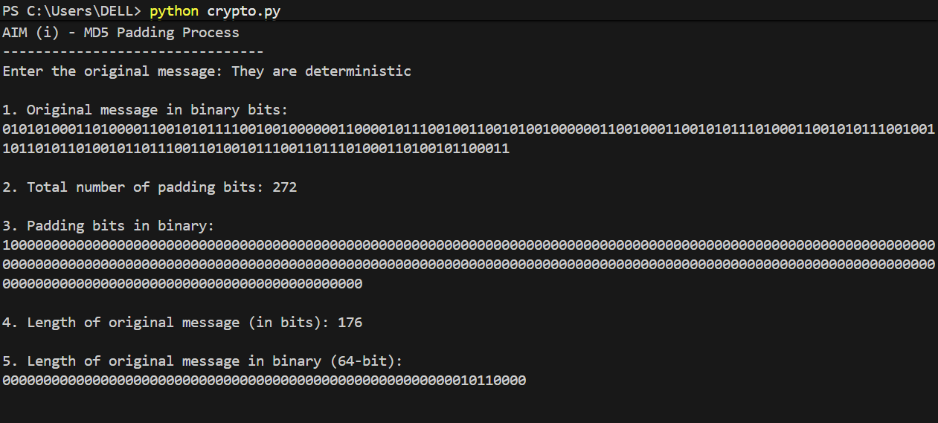

Example 2 (Aim ii): Get the input of MD buffers A, B, C & D, M0 and K1 and display the output of A, B, C & D in step 1 of Round 1.
Use the output of step1 as input of MD buffers A, B, C & D in step 2, use M1 and K2 and display the output of A, B, C & D in step 2 of Round 1.
